Dualite® E135-025D

Dualite® E135-025D is an ultra-low-density product, based on polymer microspheres externally coated with an inert material. Produced in a unique manufacturing process, Dualite® E135-025D is free-flowing with no agglomerates and is non-flammable.

Dualite® Low Density Microspheres have shown utility in a variety of end uses, including plastics, coatings and adhesives. Dualite® can reduce product weight and lower volume costs by extending or displacing more costly resins. Dualite® can provide these benefits while often maintaining end product properties.

TYPICAL PROPERTIES

Nominal Density
0.135 ± 0.015 g/cc
135 kg/m³ Mode (Peak) 15 - 35 μm
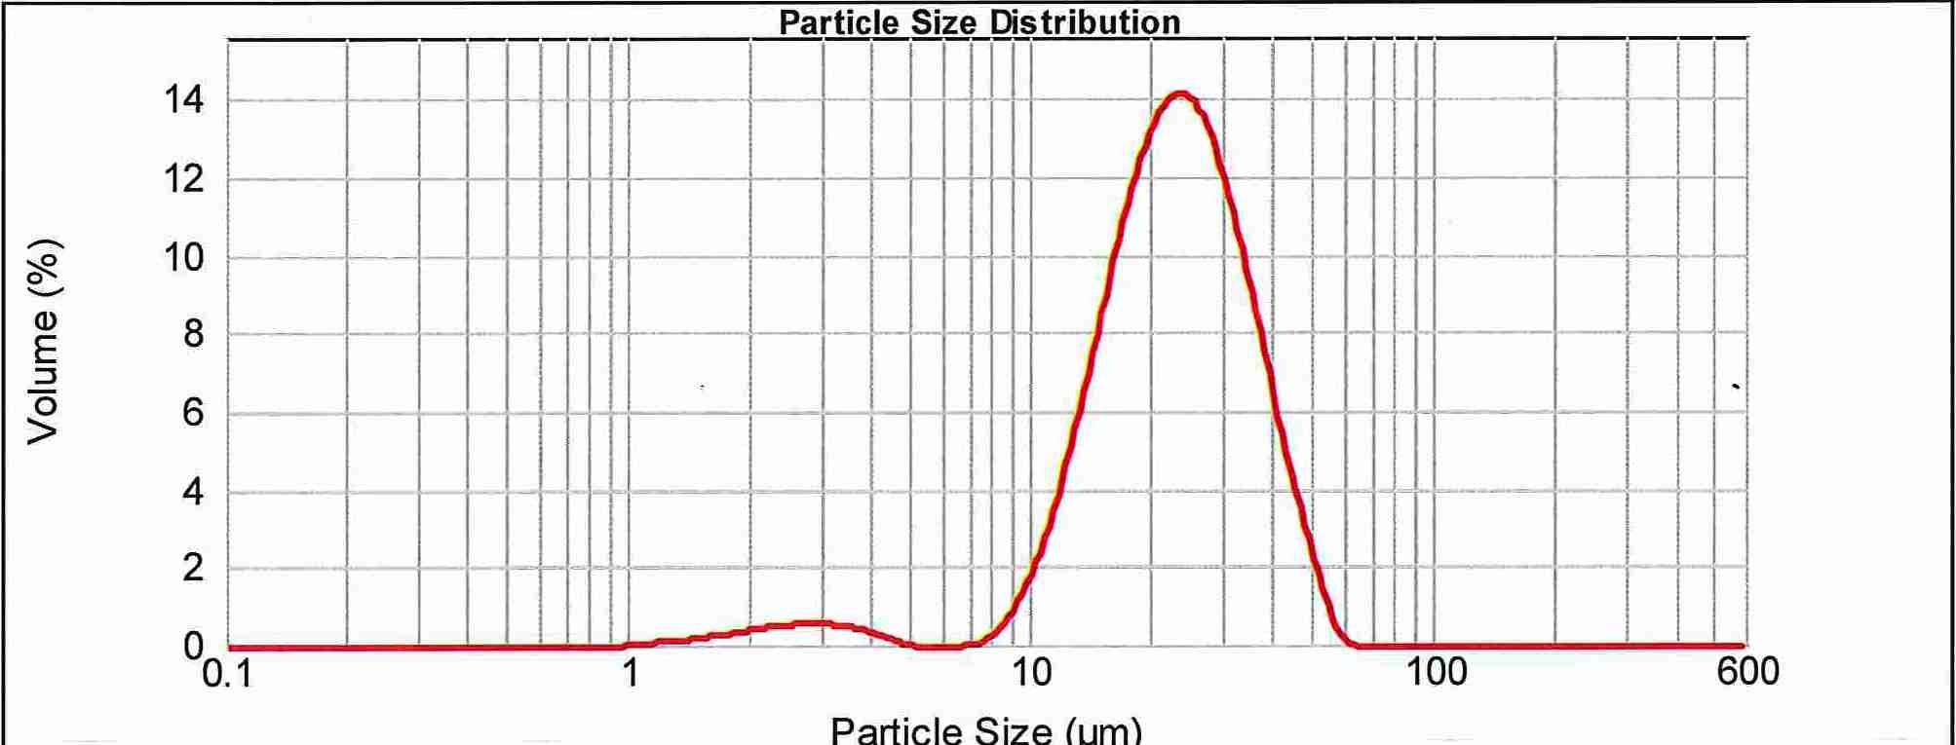
1.13 lb/gal
8.43 lb/ft³

Composite Composition

Shell - polyvinylidene chloride

copolymer
Coating - calcium carbonate Chemical Resistance
Chemical Resistance
Most aliphatics - excellent
Low esters - fair

Ketones – poor

Heat Resistance
248°F (120°C) (time dependent)
Moisture

0.2-2.0%

Shelf Life: One year from date of manufacture under proper storage conditions.
We believe the above information is reliable, however the conditions of application
and use of our products is beyond our control. No warranty is expressed or implied
regarding the accuracy of this information. This information is supplied with
the express condition that our customers will perform their own tests to determine

the suitability of this product for their particular use.

02/13



